Somer Valley Enterprise Zone (SVEZ) First Public Engagement
The initial public engagement took place between 19th May 2022 and 30th June 2022. The engagement was widely publicised via B&NES press releases, site notices, letters to neighbouring residents, social media posts and a newspaper column within the Midsomer Norton Journal.
The project team held a public webinar on 19th May, which had 41 attendees and 336 views within the engagement period. Project boards and hard copy questionnaires were installed within Midsomer Norton Library, Radstock Library and Paulton Library for the length of the engagement period. Overall, 29 hard copy and 106 online questionnaires were submitted.

Engagement Results
The data set out in the following graphs collates the questionnaire responses received during the engagement period.

Over 90% of the respondents to the engagement questionnaire were local residents. The project team will continue to take steps to ensure a greater range of people are engaged during the Local Development Order consultation, including local business owners.

The graph above records the percentage of those who would be interested at working on the SVEZ site. Please note that 15% of respondents stated they would not work on site as they are at or above retirement age. Others stated that they were happy with their current positions so would not need to relocate their employment to the site.

The general consensus of the questionnaire responses was that industrial heritage should be reflected within the design of the site. A key theme throughout responses was based on the requirement to include references to the mining heritage of the local area.

Respondents were able to record their preferences for the type of materials they wished to see used on site, with brick and timber coming through as the most popular. A popular material suggested was the use of local stone.

A high proportion of respondents stated that they strongly disagreed with the proposed layout of the site. The majority of these responses were based on disagreement with the original policy allocation as a whole and not the proposed illustrative masterplan. The same can be said for the responses to the appropriateness in the local context shown in the graph below.
The site has been allocated for employment use since 2007; the aim of this consultation was to gather consultee views on the proposed masterplan and allow residents to input on the design of the site.

Similarly, the majority of those who did not believe that the heights were appropriate were also not in favour of the development itself. The impact of the buildings within the landscape will be measured through a Landscape Visual Impact Assessment as part of the Local Development Order (LDO) submission to the Local Planning Authority (LPA).

Respondents were clear that green infrastructure is an important aspect of a new development and that this should be demonstrated through the options presented above. The development is set to be a ‘park within a park’ with green infrastructure being a pivotal part of the project.

The following graphs reflect the opinions of the public regarding the potential highways updates at the Somer Valley Enterprise Zone. It should be noted that the majority of those who do not support any of the highways mitigations say so in rejection of the scheme itself opposed to the potential highway improvements directly.

Project Updates Following Consultation
Illustrative Masterplan
The following images show the original illustrative masterplan and the amended illustrative masterplan following the informal public engagement, with changes made to the southwestern boundary of the site, in direct response to the feedback received following a residents meeting.
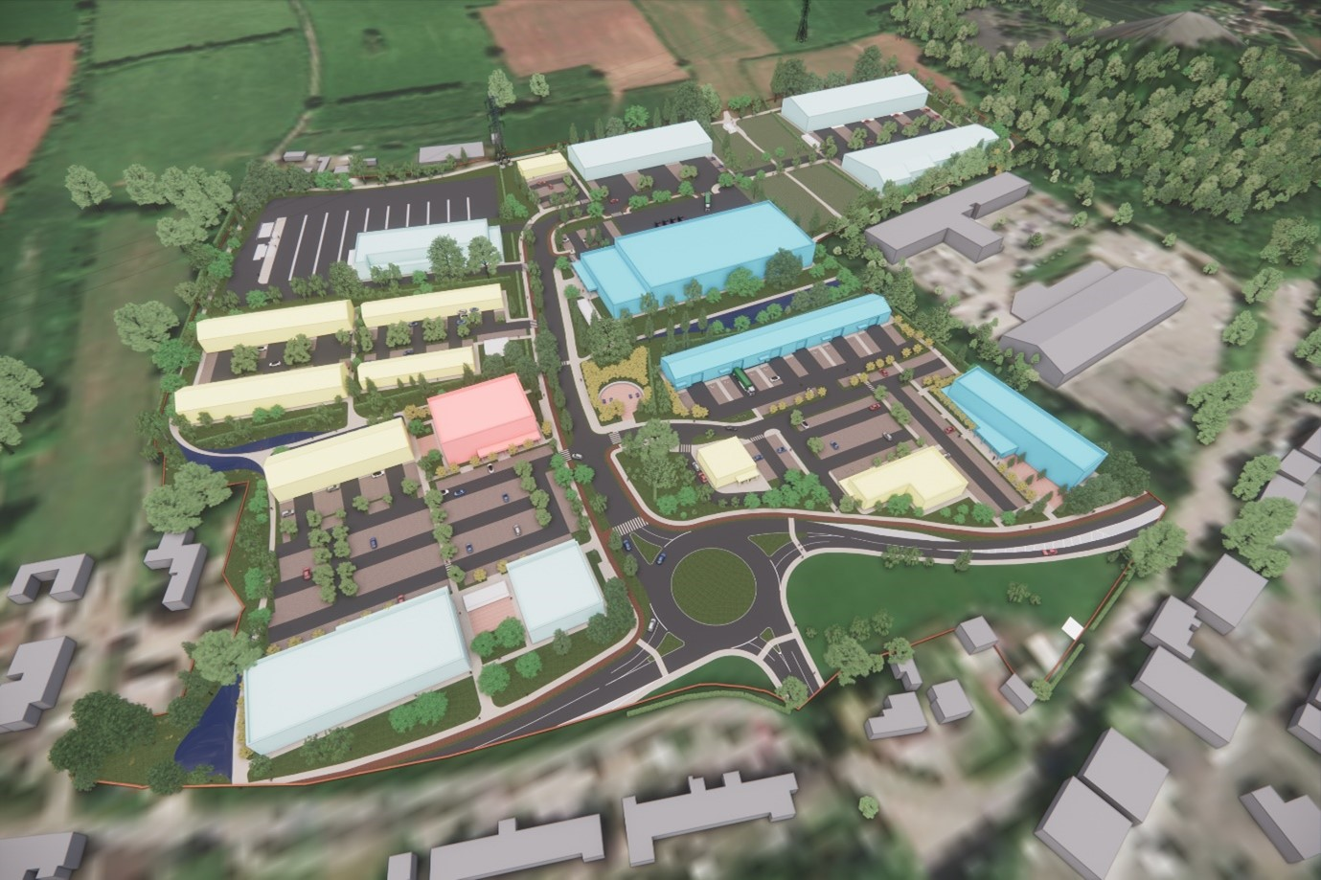
Illustrative masterplan prior to public engagement
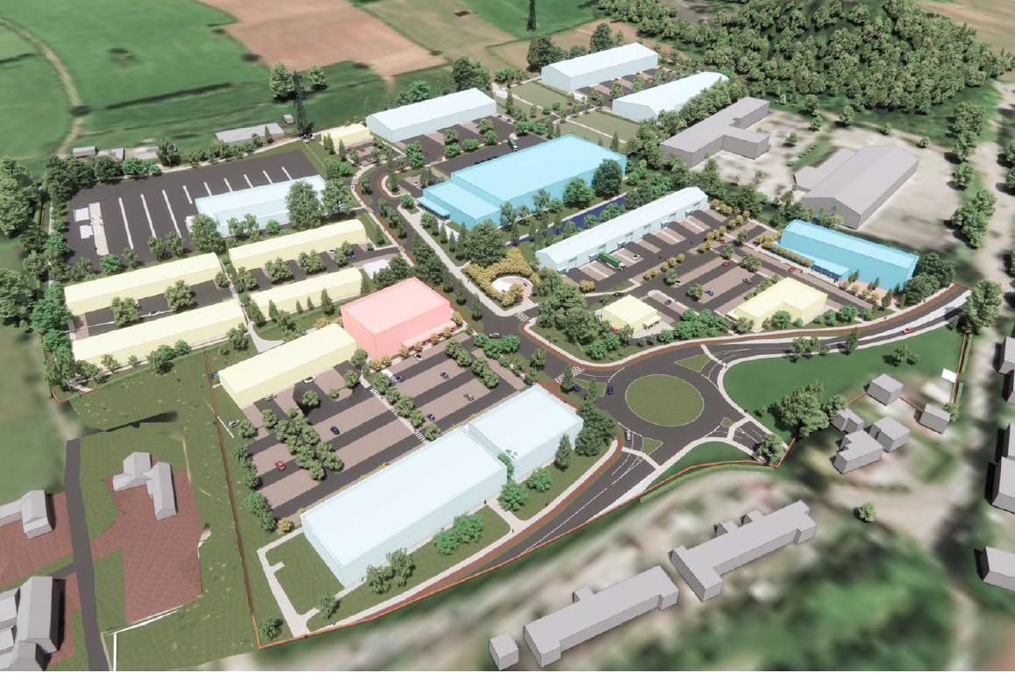
Illustrative masterplan following public engagement
Highways Updates
A number of highways updates/changes will take place to support the site and the surrounding areas. The most significant highways mitigations proposed include:
- SVEZ Roundabout: In response to residents input the design for the entrance roundabout has been amended to reduce the diameter to 40m, from 45m
- Sunnyside: The A362 at Sunnyside Cottages will be realigned to allow for the retention of the on-street resident parking and have two lanes to improve the flow of traffic. And the speed limit along the A362 is proposed to be reduced and regularised.
- Thicket Mead Roundabout: Options to improve the traffic flows through the intersection have been reviewed and workshopped with BANES highways.
- East Cycle Track: The east cycle track leading from the SVEZ to the Norton Radstock Greenway is now designed to have segregated walking and cycling lanes where the constraints allow.

