3

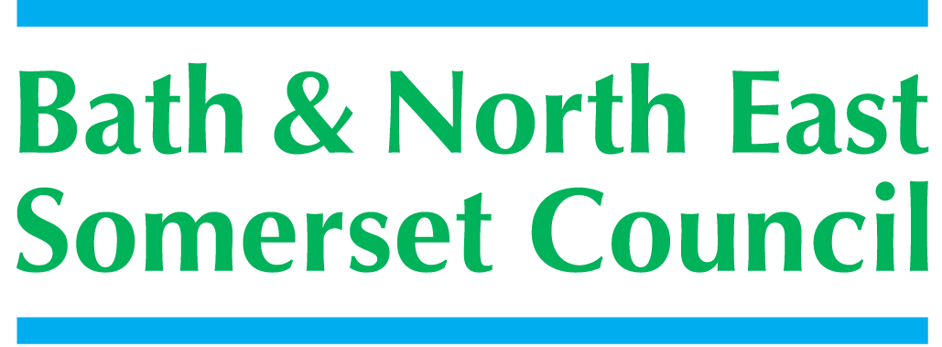

Meeting title | SCHOOLS FORUM
Date | Tuesday 28th September 2021 – via Zoom
Forum Members Present | Jo Marsh (Chair), Roz Lambert, Kevin Burnett, Jo Stoaling, Dawn Sage, Louise malik
Forum Members Not Present | Collen Collett, Sara Willis, Claire Hudson, Alun Williams, Steven Mackay, Charlotte Lucas
Observers
Officers Present | Cllr Dine Romero, Richard Morgan, Chris Wilford, Rosemary Collard, Mary Kearney-Knowles, Jo Stone (notes)
Officers Not Present
Distribution | As above
Next meeting

ACTION
1. | Apologies Received
The following apologies were received:
Alun Williams
2. | Declarations of Interest
 | All attendees were asked to complete a Declaration of Interest Form and send to Justine Kill. No conflict interest declared.
3. | Minutes of the last meeting 26th June 2021
 | The Chair went through the minutes page by page.  Minutes were agreed.  Matters Arising  JM letter to new minister regarding Early Years will be completed by the next meeting, if members have any points they want included please email  RM report on SEND review will be covered in agenda item 4  RM has supplied Kevin the comparison breakdown in a different format  KB: Requested clarification on the impact on schools of DFG loss of income.  RM: The accounting for the DFG deficit sits within the Local Authority accounts as an earmarked reserve which doesn’t need to be taken into account in the Authorities audit, it doesn’t impact on the remaining reserves of the Local Authority. This has been agreed through the DFE, Treasury & Department for Local Communities, this is in place until the end of the 22/23 financial year, irrespective of the size of the deficit it doesn’t impact on the Local Authority’s reserve.  At the end of the 22/23 financial year the DFE are planning to transfer that responsibility back to the Local Authority who will need to consider how it will recover the deficit. Through the SEN review planning to change the way the resources are Local Authority’s responsibility in relation to DFE deficits. The consultation papers specify that the Local Authority once the National Funding Formula is in place will not be able to reduce the allocations to schools to withdraw resources to support the DFG. It’s the DFE intentions to make the schools budgets ringfenced from the high needs deficits with the responsibility being with the Local Authority not schools.  It was agreed that JM would send a letter of condolence to Bath & Wells Multi Academy Trust. | JM  JM
4. | SEND spending review
 | CW updated the meeting  The review is significantly delayed, issues regarding finance and structural problems around current legislation. They are trying to combine other matters around exclusions and alternative provisions from the Timson review. They want to look at the continuing support for older vulnerable children.  Locally we have a significant financial issue we are taking steps to address this; we will be opening additional spaces with Aspire with support from the Local Authority. We have opened several resource bases at Oldfield School, have supported St Nicholas’s School & St Marks to expand their resource bases. Ongoing plans to look at post 16s with Bath Collage around the development of the residential side. The South West Section 151 officers have written to the Secretary of State highlighting their concerns around SEND pressures.  Rosemary has finished the latest version of the SEND Educational Strategy this will be sent to the SEND Strategy Group and will be brought to this forum, looking at capital builds and what we deliver and how we work with schools  Undertaken a review of all high-cost placements particularly the ones funding through the joint agency panel, we will also be formally commissioning an external review of the joint agency panel to focus on where the highest costs are.  Finishing the recovery plan which is the DFE tool that allows us to put everything in one place before its finalised, we will bring it to the members of the forum  JW: We will add the strategy group feedback to the next agenda  CW: Happy for it to be circulated in advanced and answer any questions at the next meeting. | JM
5. | DFE Guidance Update
RM: I have pulled together a brief description of all the directives on funding going forward.

For 22/23 DFE provisional allocations is that school funding is increasing by 3.2% that equates 2.81% in B&NES, individual schools will see a range between 2% - 28% in the primary sector, 2% - 5.3% in the secondary sector

The changes to the National Funding Formula that the DFE has specified centre around 3 things:
- Sparsity – recognises remote schools changing the mechanism increasing the amount of money they received and the mechanism for measuring the distance between schools.
- Free school meals – have removed the lag in funding bringing it forward to the October census
- Centralisation of Business Rates – mechanism by which they plan to implement going forward.

The sparsity factor has driven significantly increased resources to 6 primary schools within B&NES one school receiving a 28% per pupil increase. Within the consultation we are asking whether we should try and mirror the national funding formula.

High Needs Block – within B&NES an 8.46% increase, 8% per pupil the minimum % being allocated across the country. This increase is below the current overspend in SEND.

Central Services Block – Sees a reduction due to withdrawal of historical commitments for PFI and prudential borrowing. We have projected £9K reduction in resources.

Direction of Travel – commitment to move to a hard funding format, once introduced the Local Authority won’t be able reduce those factor value as they will be driven from the DFG. To be introduced in April 23/24 this will be an additional pressure to the high needs block.

Consulting on mechanism by which they will adopt elements into the national funding forum. Proposals are in-line with national expectations. No provisional allocation for early years block yet.

The central services block will be reviewed in terms of statutory responsibilities of the Local Authorities, possible the funding regime will be changed with the funding going through the Local Government finance settlement. Possible changing of funding allocations to an academic year funding allocation

6. | Nation Funding Formula 22-23
RM We now need to formally consult with schools on the changes we plan to introduce for April 22/23. Key changes are the sparsity factor and free school meals. The circulated papers show’s what the DFE are planning to do. If we mirror the National funding formula our schools budgets will increase between 2% (minimum) and 28%.

The attached appendix shows the questions we plan to formally ask.
- Should we mirror the funding formula – if we do and the resources do not mirror it perfectly - how do we reduce the resources to individual schools, a) we could limit the gain for individual schools b) adjust all factors my a small amount to bring it back in-line
- Do we continue with the ½ % transfer to the high needs block
The consultation will end on the 4th November, we will collect the results and develop a decision paper for Dine to consider, this will be published in early December
The meeting agreed that the consultation paper could be sent out.
7. | Nation Funding Formula Reforms
 | RM – Local authority officers reviewed the consultation the DFE have issued and logged our responses to the individual questions. Generally, we are in agreement with their planned approach, plans to directly advise the National Funding formula.
8 | Business Rates Payment Changes
 | RM – From 1st April the DFE will pay the rates bills of individual schools directly to the Local Authority that’s collects those rates. Letter sent to academies and maintained schools regarding buildings not used for educational purpose i.e. caretakers house need to be segregated from the business rates valuation. Schools will be informed of the amount paid on their behalf; they will be able to challenge; a payment in May with a reconciliation the following March.
9 | AOB
 | JM: Need to update the agenda attendees list to include Kate Hobbs from Bath City College as 14/16 rep and Mr Nick Lee-wells from Lansdown Park as academy rep, will be inviting them to the next meeting.  Agreed that the next meeting should take place via zoom as its likely to focus solely on consultation responses and recommendations to Dine | JM/JK
10 | Date of next meeting
 | Tuesday 16th November 2021.

